**COMPARISION BETWEEN PERFORMANCE OF DIFFERENT KINDS OF BATTERIES USED IN ROBOTIC VACUUM CLEANERS**

|  |  |
| --- | --- |
| Swati Mahapatra | Viraj Sonaje |
| Program / Plan | Program / Plan |
| School of Computing and Augmented Intelligence | |
| Arizona State University, Tempe, AZ, USA, 85281 | |

Contents

|  |  |  |
| --- | --- | --- |
| 1 | Introduction and Background | 2 |
| 2 | System Description | 2 |
| 3 | Modeling | 3 |
|  | 3.1 Model description | 3 |
|  | 3.2 Model specification | 3 |
|  | 3.3 Model implementation | 3 |
| 4 | Simulation Experiments | 3 |
| 5 | Evaluation | 3 |
| 6 | Conclusions | 3 |
| 7 | References | 3 |
| A | Appendices | 3 |

# Team Members Tasks (% effort is preliminary)

|  |  |  |  |  |
| --- | --- | --- | --- | --- |
| **List of tasks** | **Swati** | **% Effort** | **Viraj** | **% Effort** |
| 1. Introduction and background |  |  |  |  |
| 2. System description |  |  |  |  |
| 3. Modeling |  |  |  |  |
| 3.1 Model description |  |  |  |  |
| 3.2 Model specification |  |  |  |  |
| 3.3 Model implementation |  |  |  |  |
| 4. Simulation experiments |  |  |  |  |
| 5. Evaluation |  |  |  |  |
| 6. Conclusions |  |  |  |  |
| 7.References |  |  |  |  |
| Appendices |  |  |  |  |

**ABSTRACT**

An automated vacuum cleaner must have a good battery performance and smart decision-making capability since it determines how long you can use it and how it cleans the surface without disturbing the surrounding objects or humans. This project aims to develop a model, using Discrete Event System Specification (DEVS) formalisms and DEVS-Suite Java based simulator, of an automated vacuum cleaner robot. The model will run in different environments which have varying static and moving objects. We will capture the battery usages for different types of batteries based in multiple cleaners in every type of environment within a given time frame.

# INTRODUCTION AND BACKGROUND

With rapid technology development in today’s time especially in areas of robotics and IoT, our home ecosystems are becoming smarter and more automated. Home automation delivers convenience and time to the user by minimizing the effort required to accomplish their jobs. Domestic robot industry started way back in the 80s and make its presence felt increasingly in the lives of people, but it is yet to build its strong presence. However, although people were hesitant at first, but with time robots have started to adapt to our needs thus instilling faith of more and more users.

A **robotic vacuum cleaner**, sometimes called a **Robovac**, is an [autonomous robotic](https://en.wikipedia.org/wiki/Autonomous_robot) [vacuum cleaner](https://en.wikipedia.org/wiki/Vacuum_cleaner) that offers [floor cleaning](https://en.wikipedia.org/wiki/Floor_cleaning) system when a vacuum system is combined with sensors, robotic drives, programmable controllers and cleaning routines. In 1956, the American science fiction author [Robert A. Heinlein](https://en.wikipedia.org/wiki/Robert_A._Heinlein) described the concept of a robotic vacuum cleaner with a recharging dock in his novel [*The Door into Summer*](https://en.wikipedia.org/wiki/The_Door_into_Summer): "Basically it was just a better vacuum cleaner .... It went quietly looking for dirt all day long, in search curves that could miss nothing .... Around dinner time it would go to its stall and soak up a quick charge."

In 1990, three roboticists, Colin Angle, Helen Greiner, and Rodney Brooks, founded [iRobot](https://en.wikipedia.org/wiki/IRobot). It was originally into making robots for military and domestic use. It launched the Roomba in 2002, which was able to detect dirty spots on the floor, change direction when it encountered an obstacle, and identify steep drops to keep it from falling down the elevated heights. The Roomba proved to be the first commercially successful robot vacuum. Over the years, vacuum cleaning technology has come a long way from manually operated devices to currently implementing Machine Learning and Computer Vision techniques for improving its efficiency and dependency on human effort.

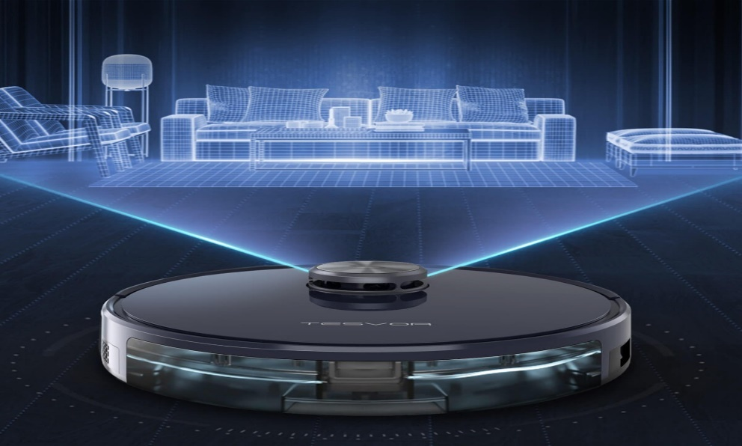

The perception that these devices are set-and-forget solutions is not always correct. Robotic vacuums are usually smaller than traditional vacuums, and weigh significantly less than its counterparts. However, a

disadvantage is that it takes an extended amount of time to vacuum an area due to its size. They are also relatively expensive, and replacement parts and batteries can contribute significantly to their operating cost.

The project is to design models of such robotic vacuums with different kinds of batteries and do case studies by comparing the battery performances when exposed to various constraints and environments. Different environments need different types of robovacs depending on the amount of work to be done thus maintaining battery levels while operating. This will serve as the purpose and objective for this project.

# SYSTEM DESCRIPTION

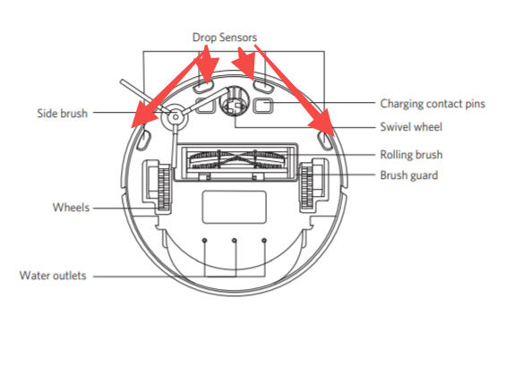

The major components of a vacuum cleaner are:

1. Intake Port (Waste bin port)
2. Exhaust Port (Bin Release)
3. Electric motor
4. Battery and its charging port
5. Percept sensors (cliff sensor, smart bumper, infrared sensor)
6. Filter
7. 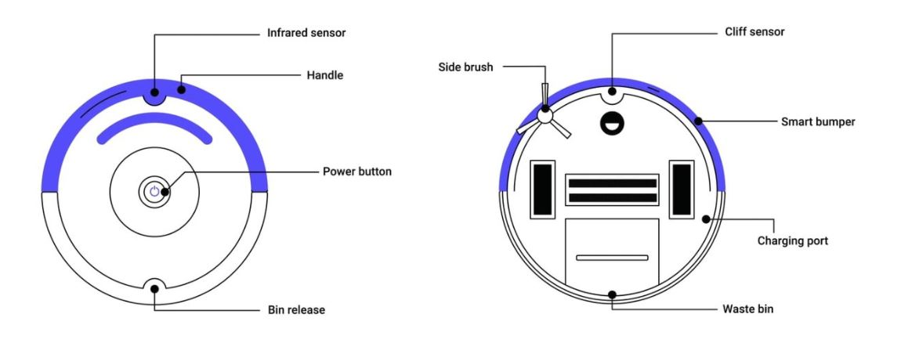Dust Compartment (waste bin)

Figure 2: Basic Components of Roomba vacuum

The regular vacuum cleaner works in the following manner:

When the motor attached to the fan creates the wanted pressure drop at the exhaust port, the ambient air is pushed into the vacuum cleaner through the intake port and the particles are suctioned into the dust compartment. The filter contains holes are small enough to stop the particles, but large enough to let the air go through. The dirty air is filtered and flows through the exhaust port.

What determines the suction power is-

* the power of the fan
* the shape of the air passageway
* the size of the intake port’s opening

The robotic vacuum cleaners aim to achieve vacuum cleaning with minimal human interaction. The cleaners operate with the same suction system but to avoid the human interaction, a self-navigation system is required. By pressing of button start or a pre-scheduling feature the cleaning robot operate through the room. The robots conventionally start their cleaning route by mapping the room to obtain the room size, either with an infrared signal or with a laser scanner. Algorithms that determine the cleaning path make them run in arbitrary patterns to finally ensure full coverage. However, same of cleaners works more systematically and creates a square of the room and operates methodically within the square. During the cleaning cycle the robots recognize obstacles with bumpers in the front or by the newest method to prevent collision with obstacles using light or acoustic waves thus avoiding the obstacles.

# MODELING

Our modelled simulation takes into account the components of ROBOVAC that contribute to major power dissipation of batteries. Following is a block diagram to give an overview of the system we have modelled:

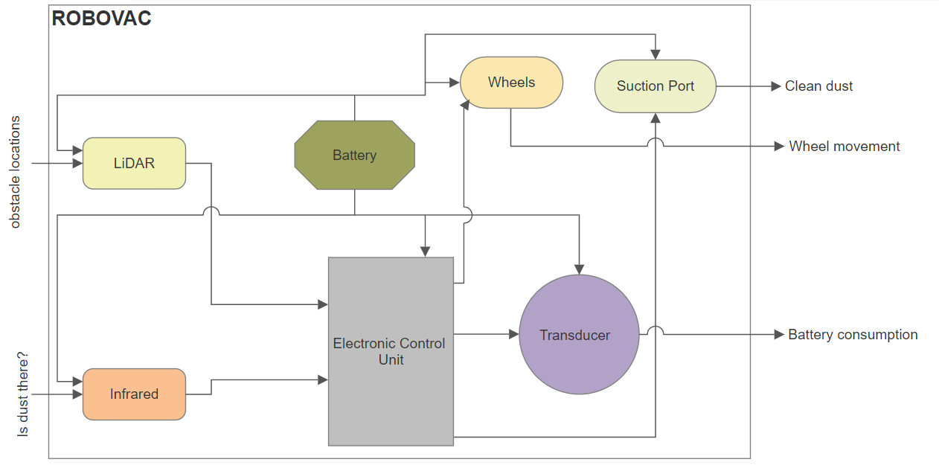

# Model description

The Automated vacuum cleaner can be realized having the following blocks:

* **Sensors**

Sensors in the bot would consist of a "light detection and ranging" or "laser imaging, detection, and ranging" (LiDAR) sensor and an Infrared (IR) sensor.

1. LiDAR sensor:
   1. It is used to scan the room and create a virtual map of the space around it.
   2. It has each environment in the form of a N X N grid having Boolean values 0 (where 0 is for obstacles/inaccessible grid block) and 1(empty grid blocks where ROBOVAC can operate).
   3. Here we have taken the assumptions that:
2. Environment is in grid format.
3. There are no moving objects in the environment.
   1. It is using grid DFS (Depth First Search) algorithm for generating the traversal path for the ROBOVAC.

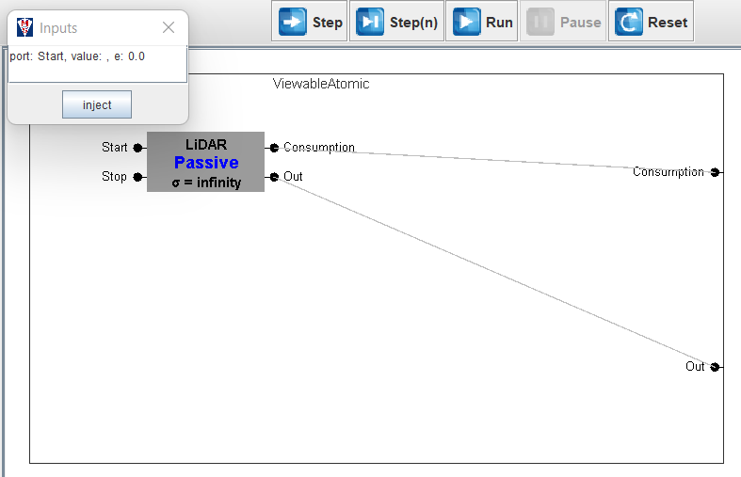

1. IR sensor:
   1. It is responsible to detect the dust on the surface to determine if a place should be cleaned.
   2. Here we have assumed the Dust Generation as an inherent feature within IR sensor atomic model.

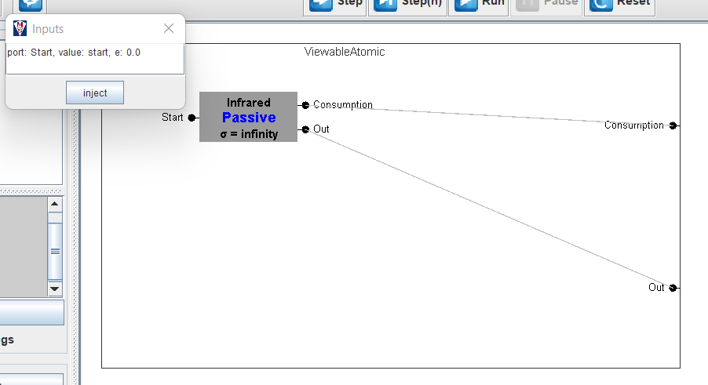

These sensors are modelled as atomic models that take input from the environment and send their findings to the electronic control unit for processing.

* **Electronic control unit**

Electronic control unit is responsible to take in all the inputs from the sensors and guide the actuators of the system i.e., the motors to take actions required at the situation. It guides the bot through the room. It decides the next cell for the ROBOVAC to move. After ROBOVAC moves to the new position, it takes dust presence input from IR sensor. If dust is found, it activates the suction pump for cleaning else it provides the instruction to move to next path cell.

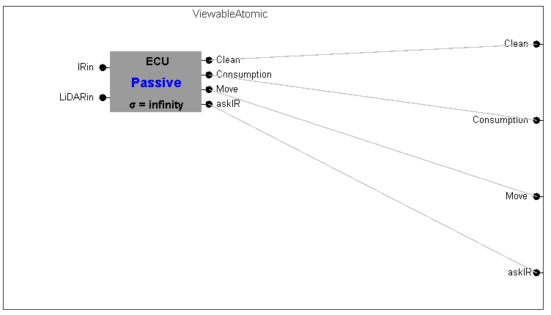

* **Motors**

Motors are used to move the wheels of the bot and to operate the suction pump. Every motor is an atomic model which gets its input from the control unit.

1. Wheel motors are triggered when the bot wants to change its location.

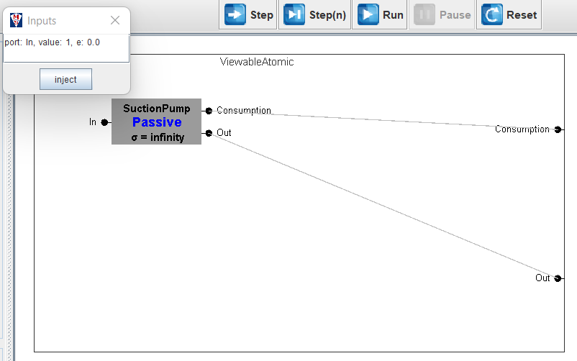

1. The suction motor will trigger when the bot wants to clean a particular area.

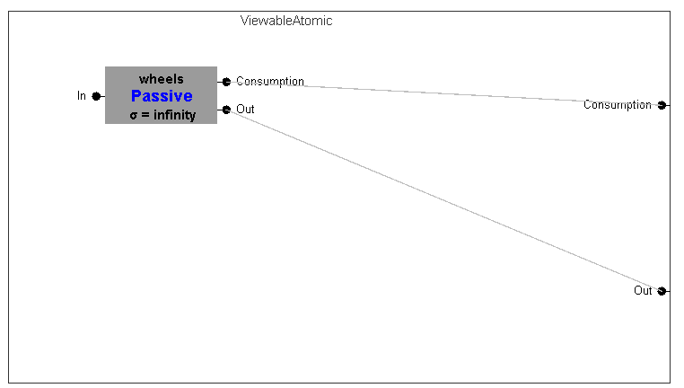

1. Every motor is modelled as an atomic model that runs for a specified time.

* **Transducer**

Transducer is being used to track the battery dissipation at each step of the ROBOVAC operation for different components. It has all the specifications for the batteries used for comparison.

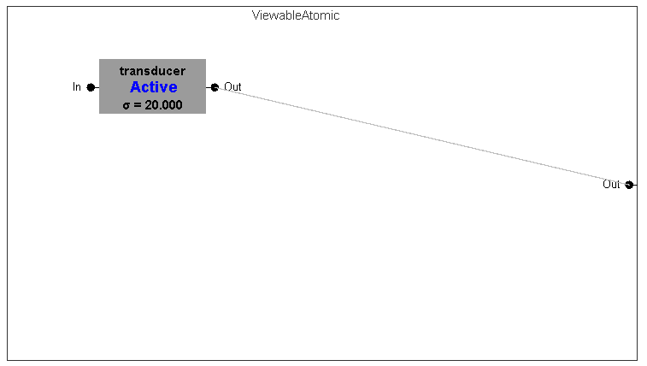

* **Power Supply/Battery**

We have considered multiple batteries for this model as an energy source and monitor its usage for every type of environment. A battery has been considered as a continuous supply of energy and its consumption will depend on the specification of the actuators and sensors and the time for which it is being used.

One of the most important point here is a battery cannot be implemented as an atomic model because:

1. Anything can be considered as a model when it consists of different states which is not the case here as we are only monitoring the battery dissipation. Hence keeping different states of the battery such as charging or discharging is rendered mute.

The following figure below give the coupled model representation of ROBOVAC for our simulation:

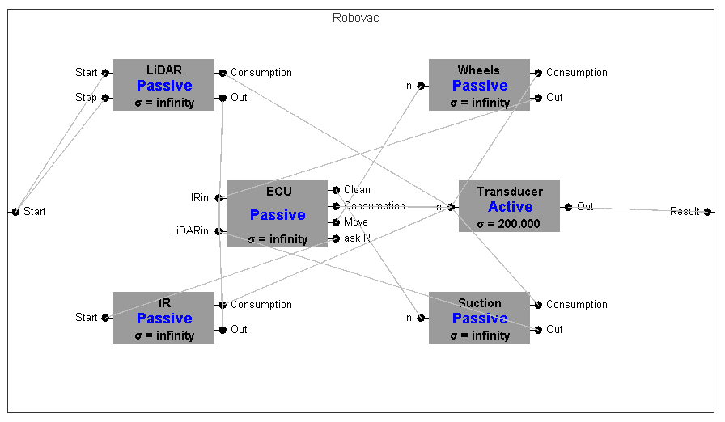

# Model implementation

# SIMULATION EXPERIMENTS

# EVALUATION

# CONCLUSIONS

# REFERENCES

# A APPENDICES

# Rubric for the Description and Modeling section.

Model descriptions (IOFO, atomic, and coupled): [30 points] Structure: [10 points]

Behavior: [10 points]

Model specifications (pseudo code, mathematical, diagrams, …): [20 points]

# Rubric for the Simulation Experiments section.

Experiments description and high-level design (generator and transducers are identified: [10 points]

Details about input data (including units) and output data: [5 points] Experiment scenario example: [5 points]